House Price Prediction — Summary of Findings
Poorvi Sharma | Internship Project, Week 1 | Dataset: Kaggle Housing Prices Dataset (545 properties, 13 features)

Model Performance
Two regression models were trained on an 80/20 train-test split to predict house price from 12 property features (area, bedrooms, bathrooms, stories, amenities, and furnishing status).
Model | MAE (₹) | RMSE (₹) | R² Score
Linear Regression | 970,043 | 1,324,507 | 0.653
Random Forest Regressor | 1,022,560 | 1,401,497 | 0.611
Linear Regression slightly outperformed Random Forest on this dataset, explaining about 65% of the variation in price (R² = 0.65) with a typical prediction error of roughly ₹9.7 lakh. On a small dataset (545 rows) with fairly linear feature relationships, the simpler model generalized better than the more complex one.

Actual vs. Predicted Prices
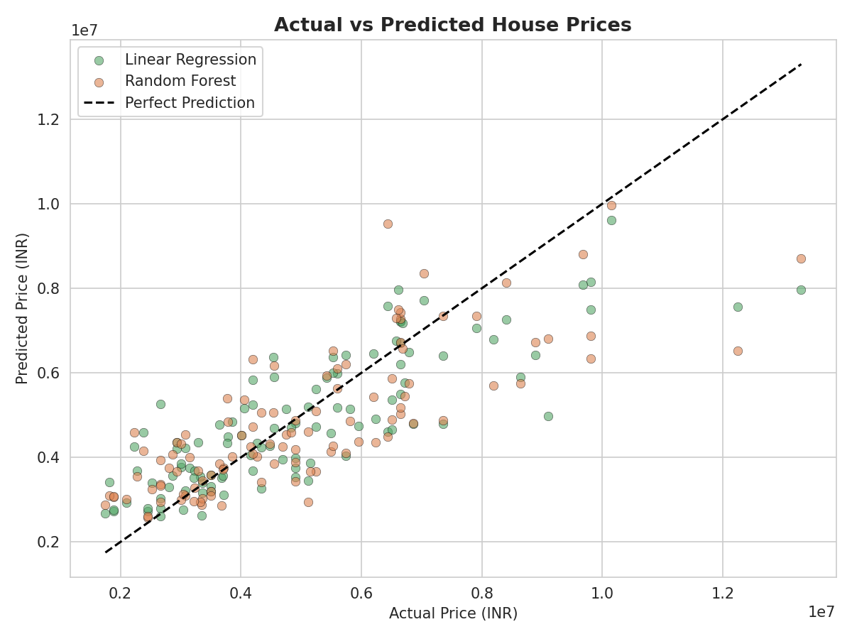

Key Insights
- Biggest price drivers: area is by far the strongest factor (47% feature importance, 0.54 correlation), followed by bathrooms and air conditioning. Bathrooms matter more than bedrooms.
- Model accuracy in plain terms: predictions are typically within about ₹9–10 lakh of the actual price — useful as a ballpark estimate, not a final valuation.
- Surprising finding: unfurnished houses carry a notably negative price correlation (-0.28), and the simpler Linear Regression model beat Random Forest, showing that more complex models aren't always better on small datasets.
- Recommendation: real estate businesses should prioritize accurate area and bathroom-count reporting in listings, and consider that adding a bathroom may raise resale value more than an equivalently sized extra bedroom.

